Encarnacion, Gerald R.

2 ECE – A

SCREENSHOTS

CONGRATULATIONS, YOU WON!

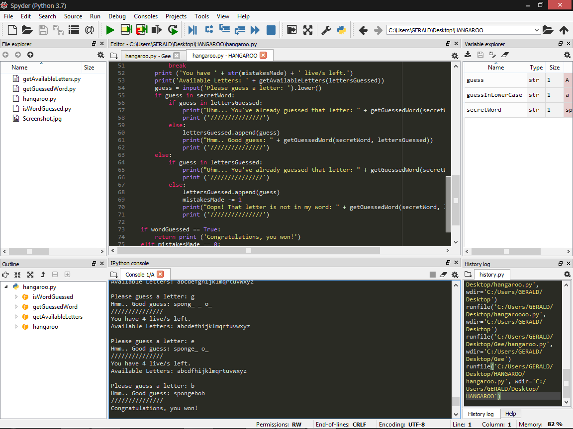

SORRY, YOU RAN OUT OF LIVES

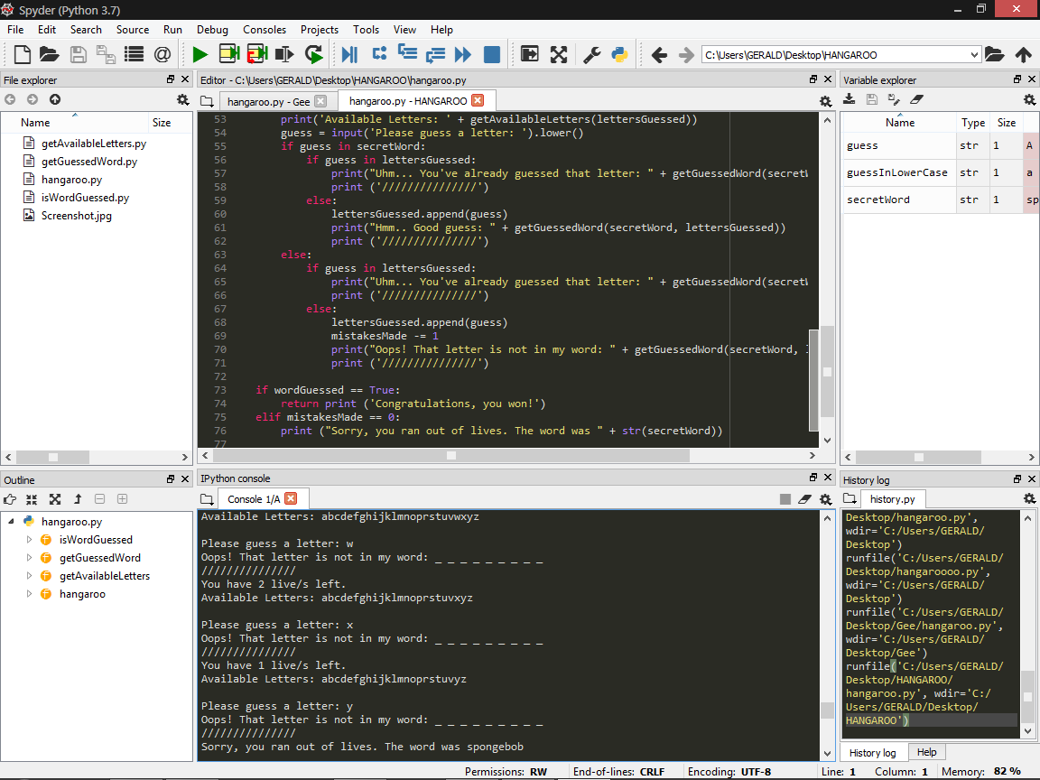

YOU’VE ALREADY GUESSED THAT LETTER

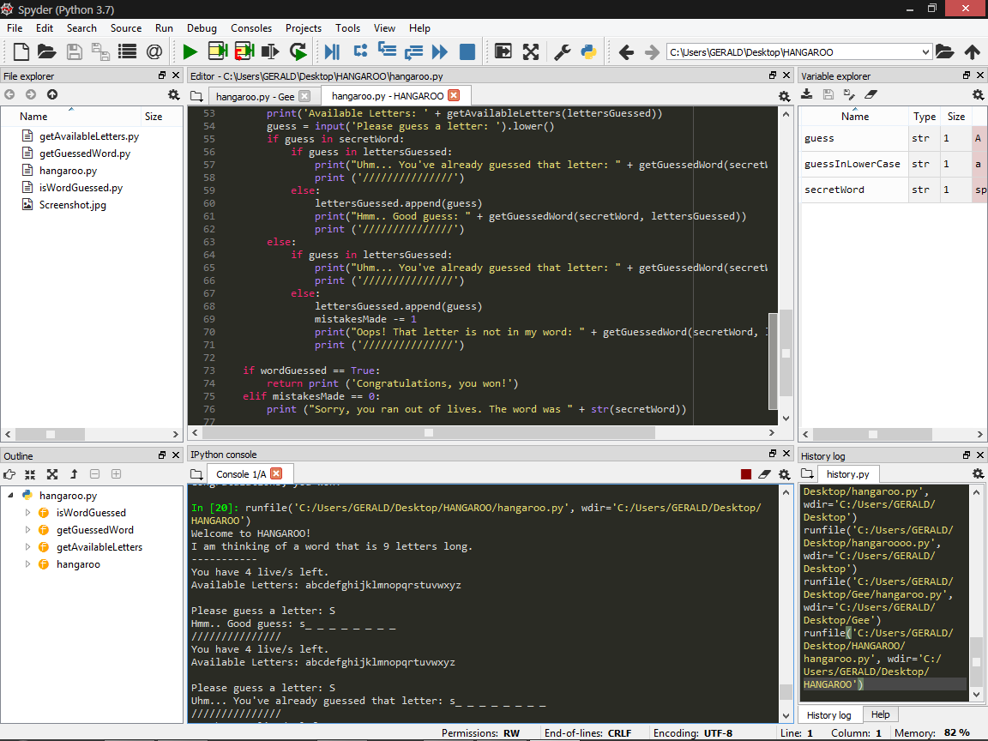

THAT LETTER IS NOT IN MY WORD

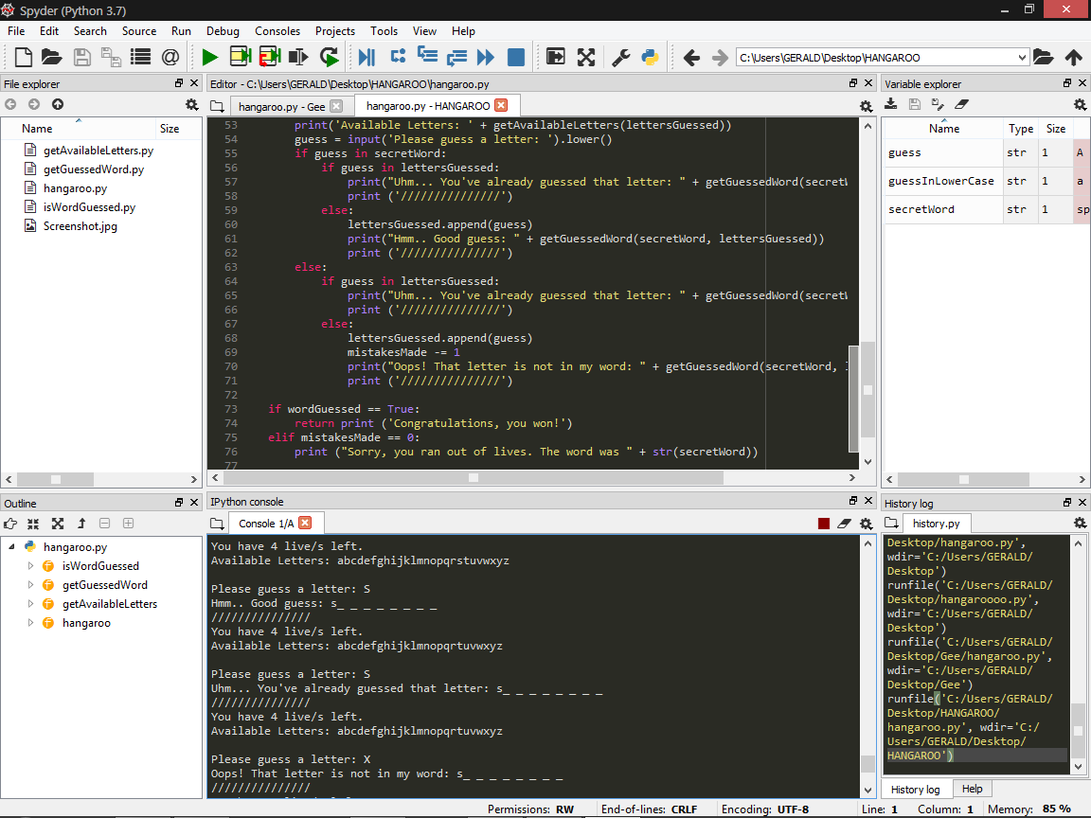

HANGAROO FILE WITH THE OTHER 3 FUNCTIONS

